Teledu
Pryd wyt ti’n gwylio’r teledu?

Resource | Teaching and Learning | Notes
Power Point  Pryd  Slide 1  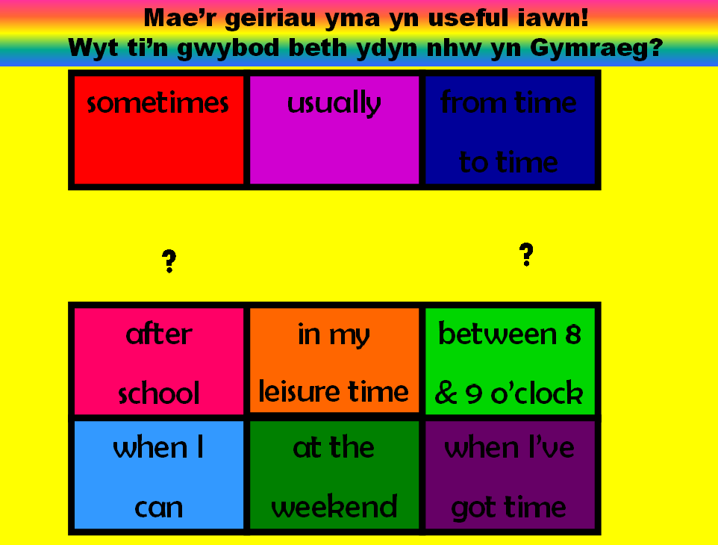 | - Encourage the use of thinking sills to understand useful words by answer the question ‘Pryd?’ (When?)  - Click 1 reveals vocabulary in English.  - Click 2 ask pupils what question do these words and phrases answer.  - Click 3 reveals that the question is ‘pryd’.  - Click 4 reveals instructions and causes words to flash. Pupils to work in pairs to translate the words. Dictionary use is optional but not necessary.  - Click 5 highlights one word. Ask pupils for its translation  - Click 6 reveals the translation.  - Each click does as above for the remaining words.  - With the remaining useful words and phrases pupils should be able to give a full answer to the question. It is important that the teacher demonstrates by giving a few possible sentences.
Slide 2  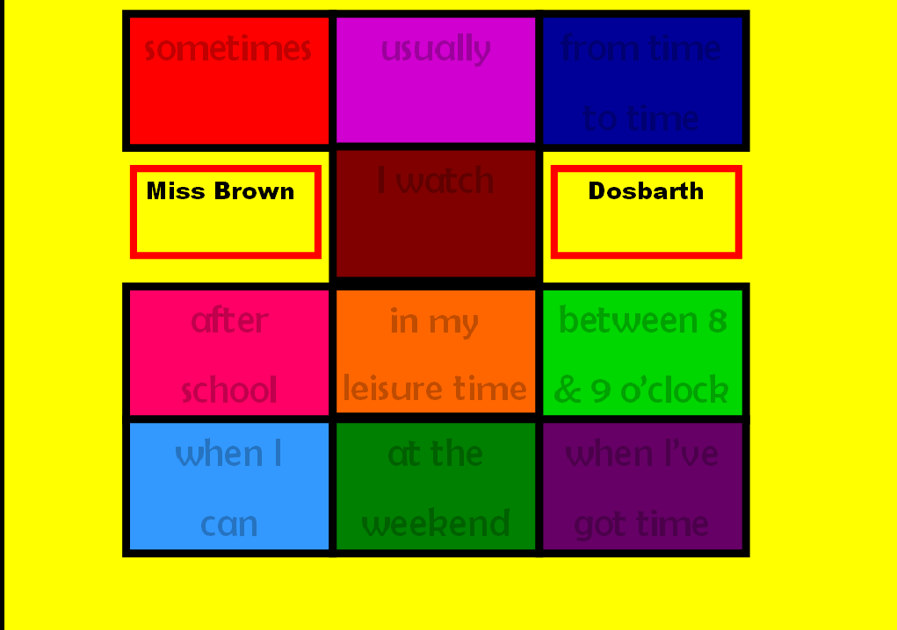 | - Use the grid to play vocabulary games as you would with pictures, e.g. teacher vs pupils, point and shout out, missing words etc.
Word Document  Pryd wyt ti’n  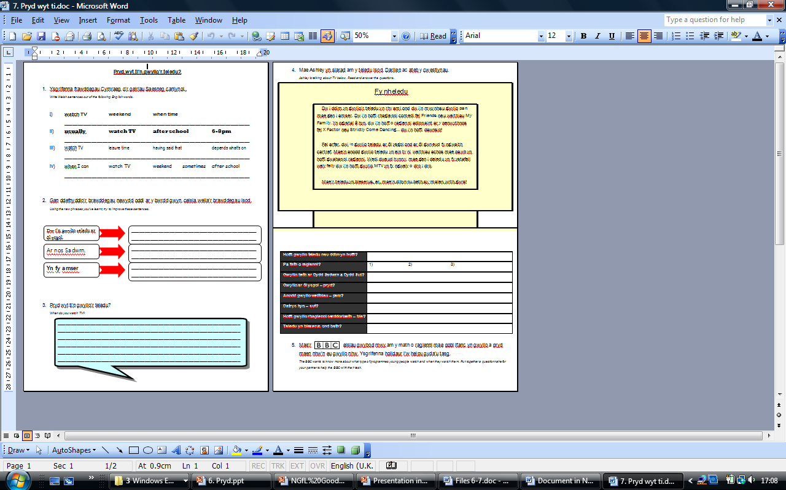 | - Pupils to follow instructions to complete tasks in order to consolidate and have a record of their learning.  - Discuss answers to reading task 4 as a class, making reference to reading comprehension skills.  - In order to ensure successful completion of task 5, revise how to structure questions. | Good opportunities here for peer assessment.  Task 2: Complete on whiteboards in pairs, share ideas with the class and the class to decide upon the best sentence, pupils may then write the best collaborative example in the space provided.  Task 3: Pupils to read aloud to each other.  Task 5: Could be completed using suitable questionnaire ICT software.

